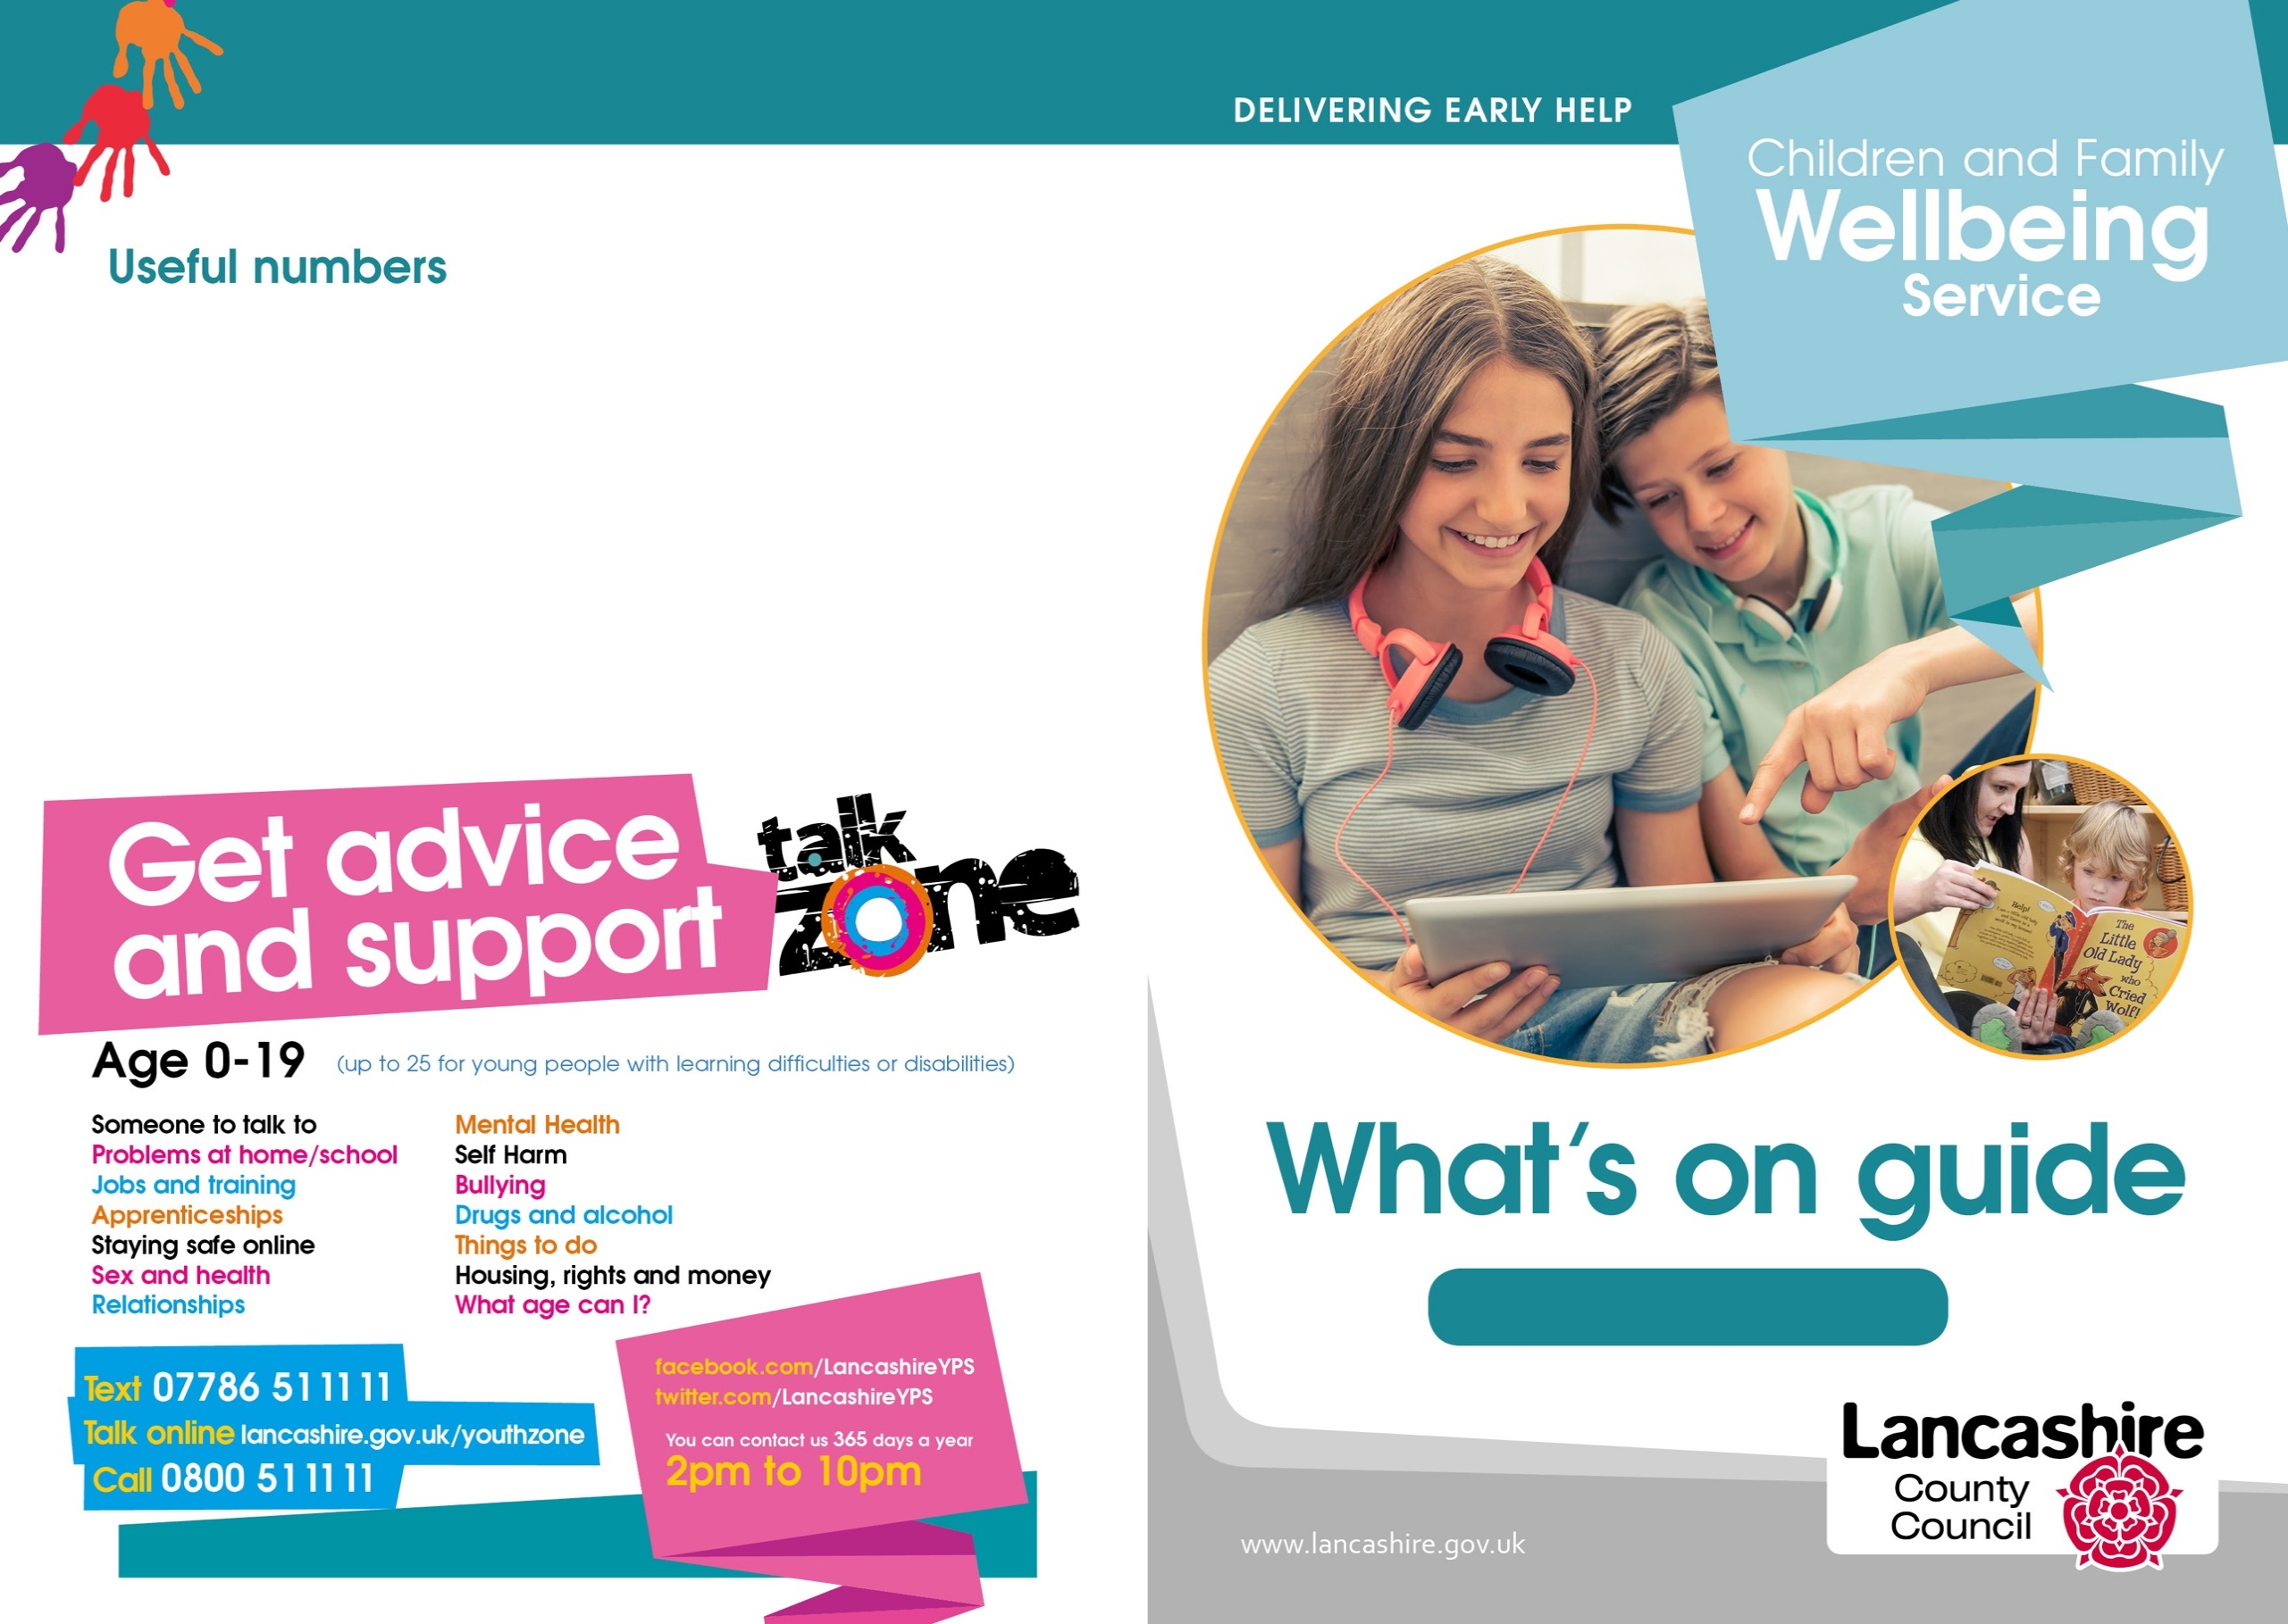

**Citizens Advice Bureau:** 0300 3301172

**Community Midwives:** 01772 524496

**Family Information Services:** 0300 1236712

**Gateway Housing:** 0800 9530213

**Health Visitors:** 03002470040

**Job Centre Plus:** 0845 6043719

**Preston City Council:** 01772 906907

**Tax Credits:** 0345 3003900

**Children's Social Care:** 0300 1236720

**Preston**

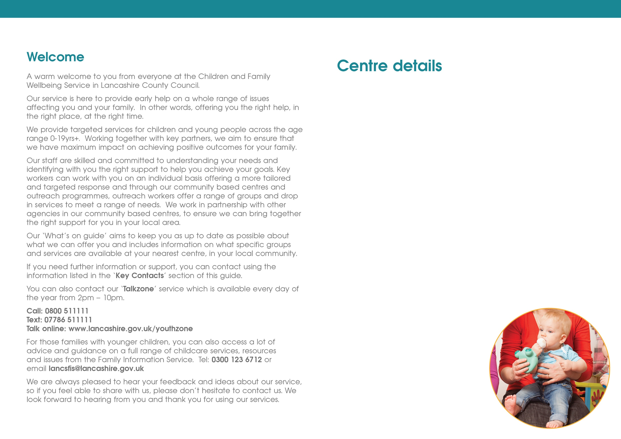

**Ribbleton CFW Services**

Ribbleton Hall Drive

Ribbleton

Preston

PR2 6EE

Telephone: 01772 539444

**Stoneygate CFW Services**

Lennox Street

Preston

PR1 3XU

Telephone: 01772 537898

**Moor Nook CFW Services**

Burholme Road

Ribbleton

Preston

PR2 6HN

Telephone: 01772 539460

**Preston Central Neighbourhood Centre**

Brieryfield Road

Preston

PR1 8SR

Telephone: 01772 531948

**Preston East CFW Services**

Brookfield Primary School

Watling Street Road

Preston

PR2 6TU

Telephone: 01772 539420

**Preston West CFW Services**

Ashton Primary School

Ainsdale Drive

Ashton-on-Ribble

Preston

PR2 1TU

Telephone: 01772 536410

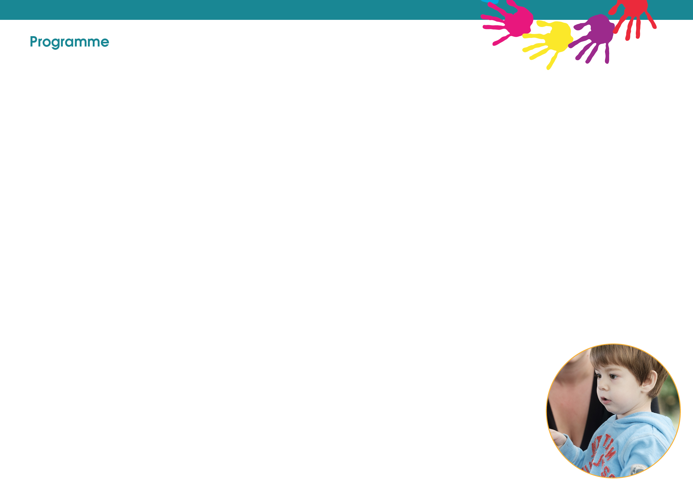

**Ribbleton**

**Monday**

Messy Play

Chat, Play and Read

10:00am – 11:30am

**Tuesday**

Triple P 0-12 years

Starts 14th January

9:30 – 11:30

(Booking Essential)

**Wednesday**

Baby Clinic

(Health Visitor led)

9:00am – 11:00am

Baby Chat, Play and Read

9:30am – 10:30am

**Thursday**

European Hungry Little Minds

Chat, Play and Read

10:00am – 11:30am

Simon Says

Chat, Play and Read

(Invitation Only)

1:15am – 2:15am

Booking Clinic

(Appointment Only)

1:00pm – 4:00pm

**Moor Nook CFW Services**

**Tuesday**

Twilight Youth Group

(Year 3-6 pupils)

4:00pm – 5:30pm

Preston Kicks

(12-19yrs)

7:00pm – 8:30pm

Street Based Work

6:30pm – 9:30pm

**Wednesday**

Create and Bake

(Booking essential)

1:00-2:30pm

Clubbercise

(Girls aged 12-19yrs)

5:00pm – 5:45pm

**Thursday**

Twilight youth group

(Year 7 and 8 pupils)

6:45 – 8:45

**Friday**

Youth Group (12-19yrs)

6:30pm – 8:30pm

**Preston East CFW Services**

**Monday**

Booking Clinic

(Appointment Only)

9:00am – 12:00pm

**Wednesday**

Little Tinkers

Chat, Play and Read

9:30am – 11:00am

**Thursday**

Baby Clinic

(Health Visitor led)

9:00am – 10:30am

Baby Chat, Play and Read

9:30am– 11:30am

Nurture group

(Invitation only)

4:00pm – 5:30pm

**Friday**

Triple P Teen

Starts 17th January

9:30 – 11:30

(Booking Essential)

**Other available groups and courses**

**LGBTQ+**

Please call in or ring your local centre for more information

**Now Running Freedom programme**

Please call in or ring your local centre for more information

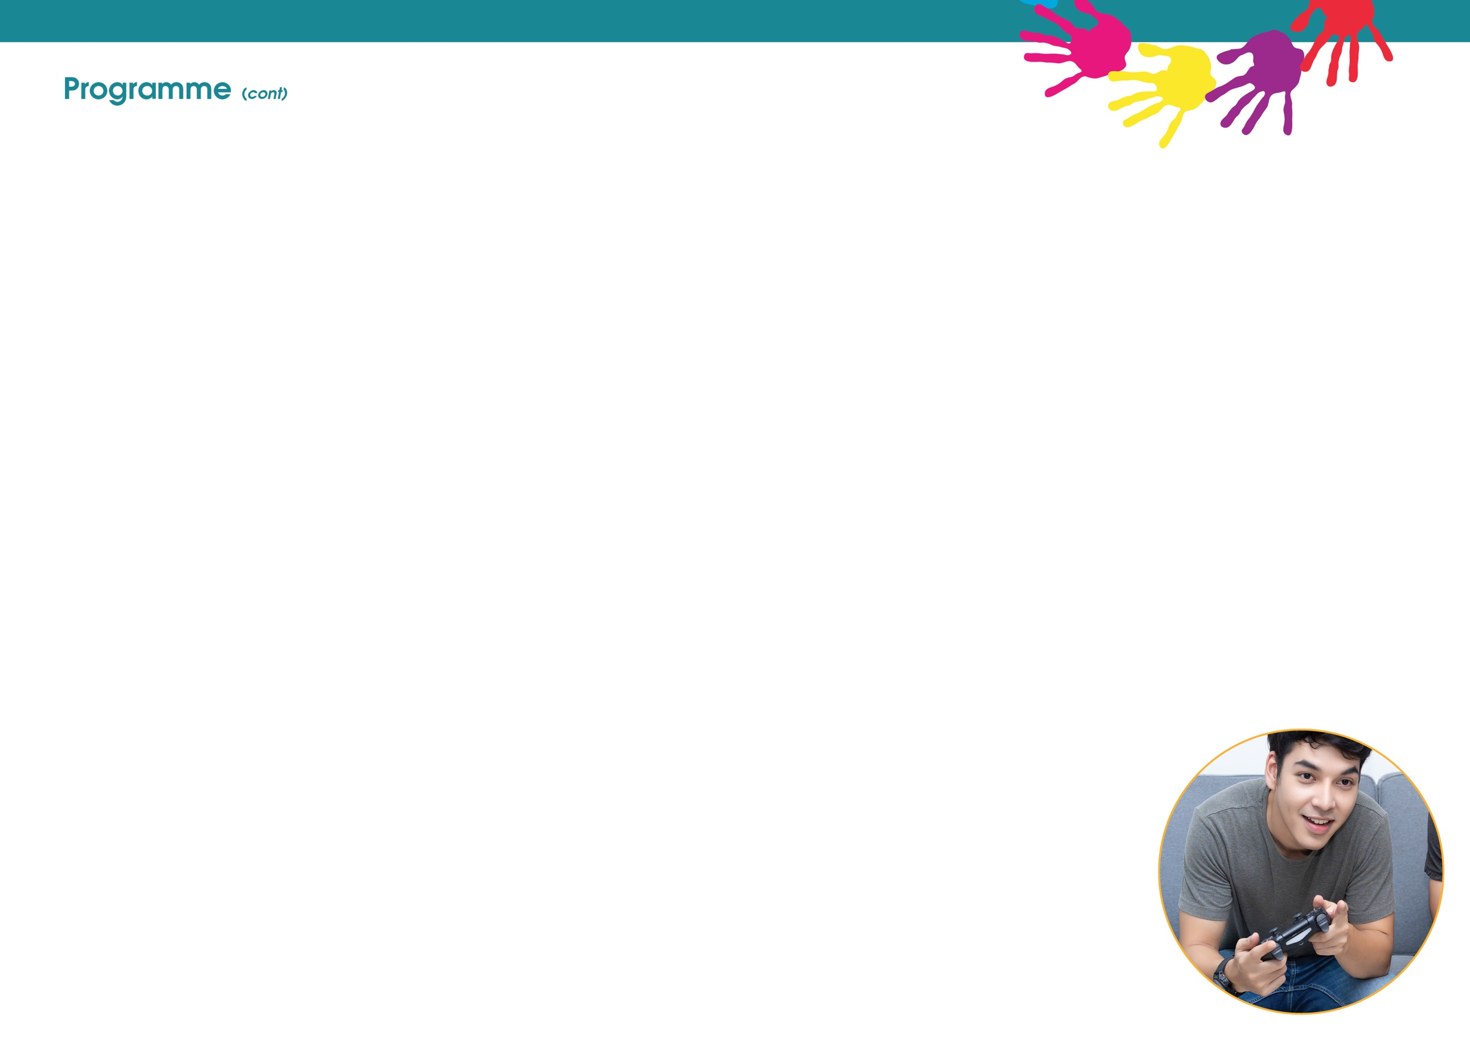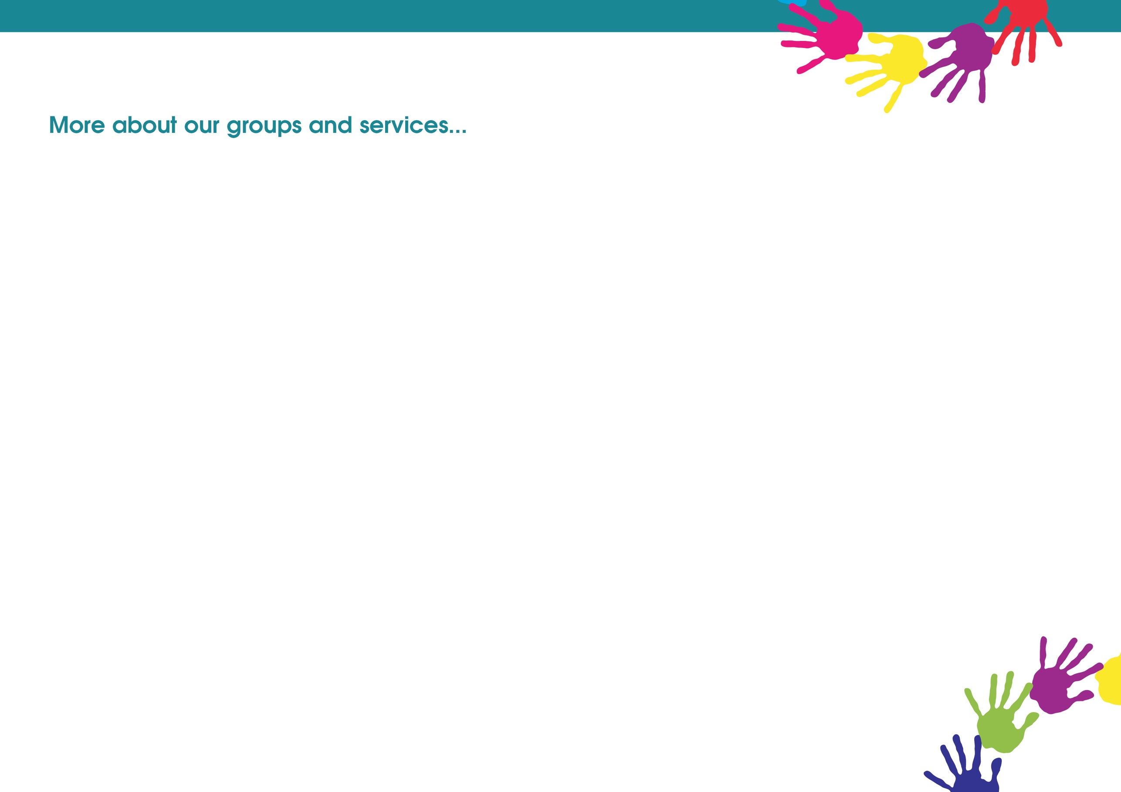­

**Preston Central Neighbourhood Centre**

**Monday**

Booking Clinic

(Appointment only)

9:00am – 12:00pm

**Tuesday**

Booking Clinic

(Appointment only)

9:00am – 12:00pm

**Wednesday**

Rainbows (SEND)

9:45am – 11:30am

**Thursday**

Hungry Little Minds

Chat, Play and Read

10:00am – 11:00am

Baby Clinic

(Health Visitor led)

1:00pm – 3:00pm

Baby Chat, Play and Read

1:30pm – 2:30pm

**Preston West CFW Services**

**Monday**

Booking Clinic

(Appointment Only)

9:00am – 12:00pm

Midwife Clinic

(Appointment Only)

1:00pm – 4:00pm

**Tuesday**

Baby Massage

(Booking Essential)

10:00am – 11:30am

Baby Chat, Play and Read

1:30pm – 2:30pm

**Wednesday**

Booking Clinic

(Appointment Only)

9:00am – 4:00pm

**Thursday**

Simon Says

Chat, Play and Read

(Invitation Only)

10:00am – 11:00am

**Friday**

Booking Clinic

(Appointment Only)

9:00am –3:00pm

**Stoneygate CFW Services**

**Monday**

Baby Chat, Play and Read

10:00am – 11:30am

Transitions Triple P course

Starts 23rd March

12:30 – 2:30

(Booking Essential)

**Tuesday**

Booking Clinic

(Appointment Only)

9:00am – 12:00pm

Hungry Little Minds

Chat, Play and Read

1:00pm – 2:30pm

**Wednesday**

Hungry Little Minds

Chat, Play and Read

(Millbank Court Residents Only)

1:30pm – 2:30pm

**Thursday**

Jumping Jacks

(Delivered at Fishwick Primary School)

10:00am – 11:30am

Youth Council

(Every other week)

6:00pm – 9:00pm

**Friday**

Booking Clinic

(Appointment Only)

9:00pm- 12:00pm

**Please check our Facebook page for regular updates and session changes.**



**Preston Family Zone**

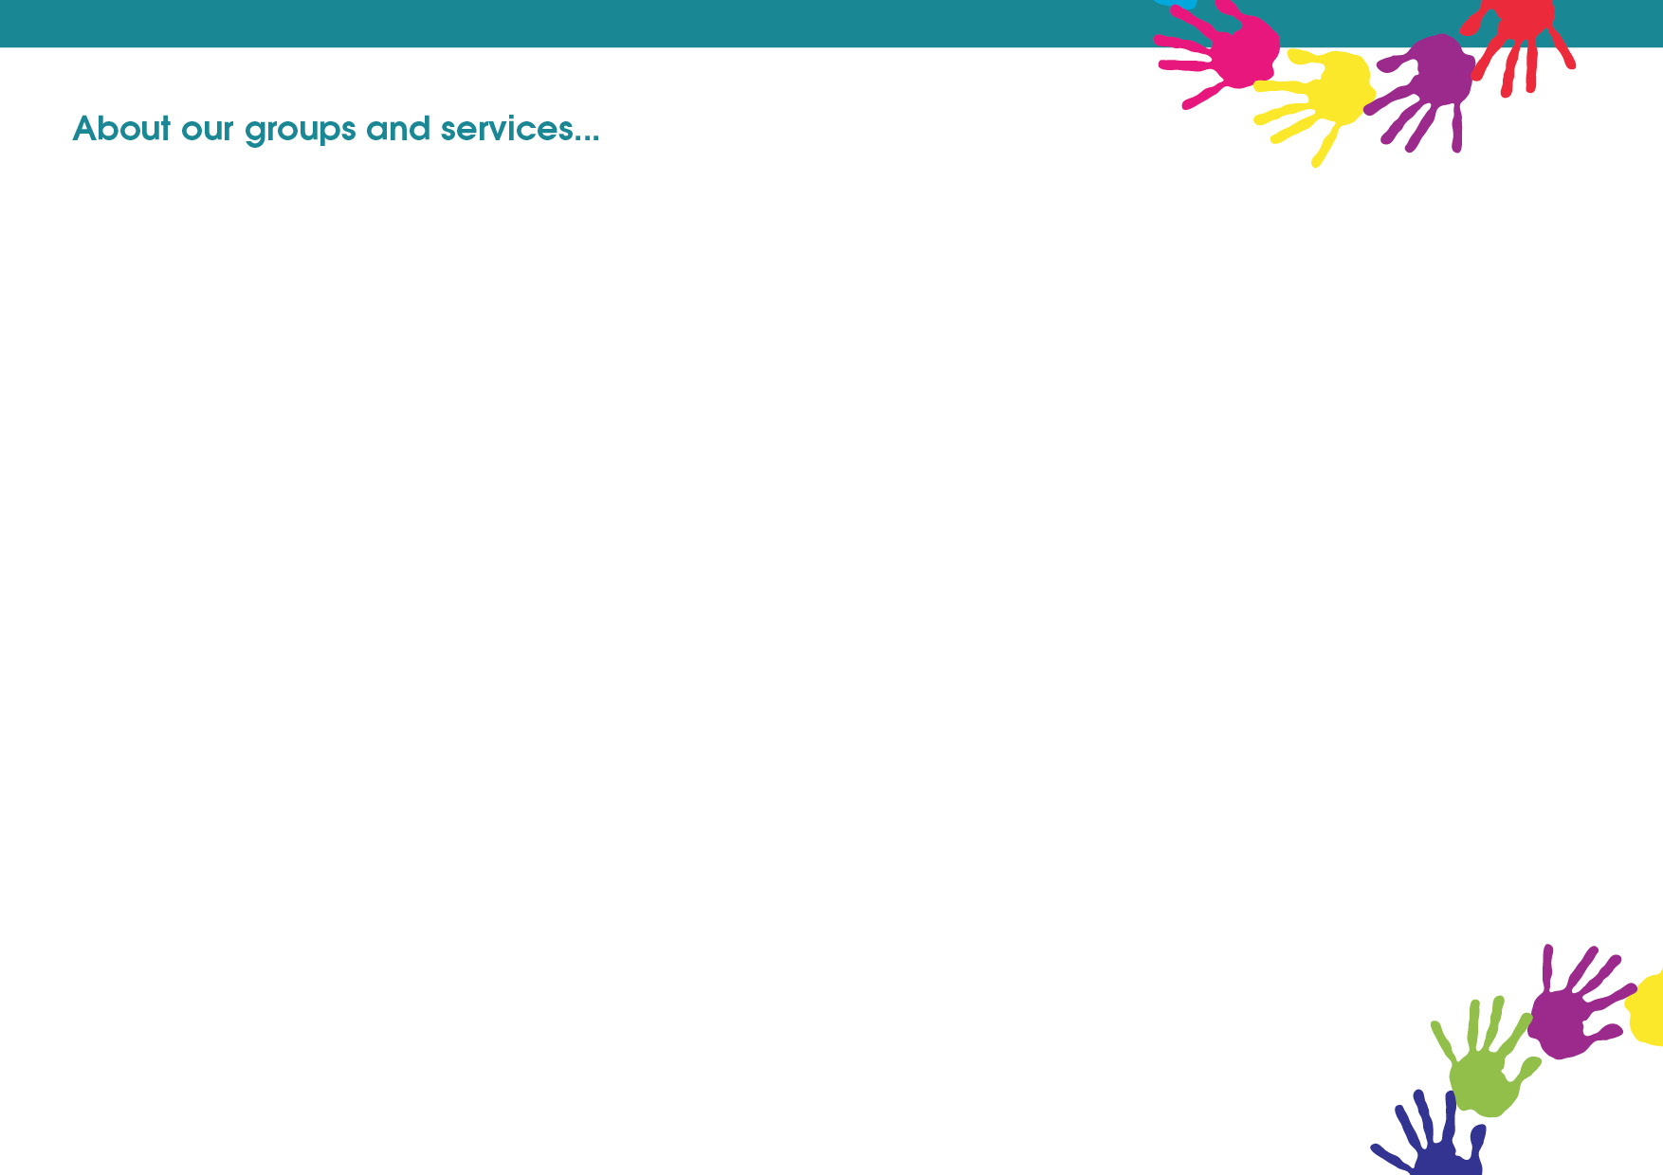

**Simon Says, Chat Play and Read (speech and language group):** (invitation only) this group supports and encourages children 2 years through to school age to develop their speech and language. Parents will be given support to extend their child's vocabulary by reading lots of stories, singing rhymes and modelling speech.

**Baby Massage:** birth to crawling, to promote nurturing touch and communication. Please bring a towel with you!

**Baby Clinic:** get your baby weighed by the Health Visitors. The Health Visitors and staff from the Children and Family Wellbeing Service will be on hand to give practical advice and support on a range of topics whilst being able to signpost support.

**Hungry Little Minds, Chat,Play and Read:** is aimed at play and interaction with your child (0-5yrs). A fun group which has indoor activities for parents, children and their siblings. It helps parents to understand the age and stage of development of their child.

**Rainbows (SEND):** providing a safe and welcoming environment for young people with special educational needs and disabilities. The group aims to work on life skills, improving communication skills, self-confidence and self-esteem in a group work setting. Parents and carers are welcome to attend.

**Street Based Work:**  this allows our Neighbourhood Workers to engage with young people within the community in which they live. They will create an environment in which young people can feel comfortable to discuss issues that affect them and evaluate with the young people any future support needed.

**Baby Chat,Play and Read:** aimed at parents and carers with babies who are Pre-walkers. A time to enjoy one to one time with your baby to support attachment and bonding.

**Messy Play Chat play and Read:** is aimed at play and interaction with your child (0-5yrs). Let your children explore different textures and experiences through a range of sensory activities. It helps parents to understand the age and stage of their child's development. Staff will be on hand to give practical advice and support on a range of topics whilst being able to signpost to support.

**Midwife Clinic/Booking Clinic:** appointments with your midwife ante and post-natal. Staff from the Children and Family Wellbeing Service will be on hand to give practical advice and support on a range of topics whilst being able to signpost to support.

**Bump, Birth and Beyond (BBB):** is an antenatal course that is run in partnership with the Children and Family Wellbeing Service, Midwives and Health Visitors. It supports parents to be through pregnancy and beyond. The programme provides you with relevant information to help you make informal choices about birth, preparation for the birth as well as key messages about infant feeding, safer sleep, play, communication and taking care of your new baby. Please contact your nearest centre to book onto the course.

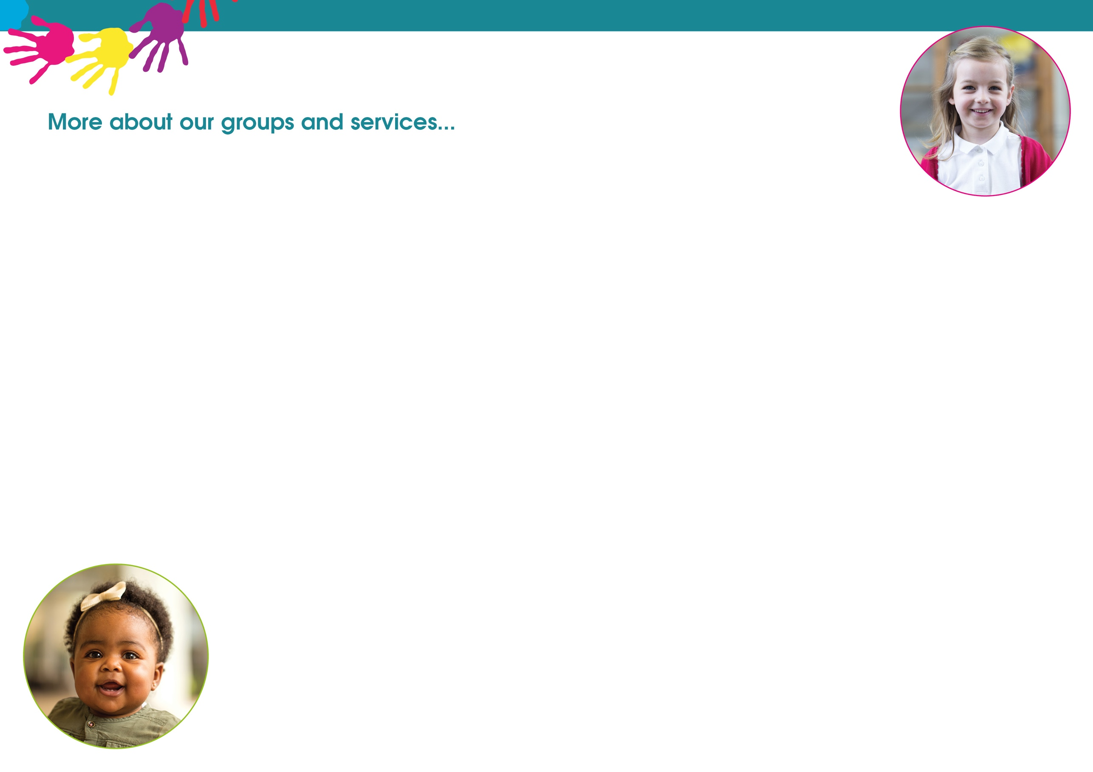

**Triple P:** is a parenting programme, but it doesn’t tell you how to be a parent! It's more like a toolbox of ideas. You choose the strategies that you need. You choose the way you want to use them. It's all about making Triple P work for you. The three P's stand for Positive Parenting Programme; which means your family life is going to be much more enjoyable. Please contact your local centre to find out more about Triple P and for details of the support that is available.

**Youth Group (8-11yrs):** an opportunity to take part in a variety of games and activities to help to build confidence and self-esteem and set boundaries. Meet with other young people and discuss the issues that they might find themselves struggling with.

**Jumping Jacks:** aimed at supporting the physical development of your child using sensory play, messy play, treasure baskets, tummy time, rhymes and singing. These sessions will be delivered from Fishwick Primary School.

**European Hungry Little Minds, Chat, Play and Read :** a weekly group aimed at bringing together Eastern European families to chat play and read with their children. Contact Ribbleton Neighbourhood Centre for more information.

**Healthy Start Vitamins:**  you can now collect your free vitamins from Children and Family Wellbeing Service centres. Healthy Start vitamins contain vitamins A, C and D for your child and folic acid and vitamins C and D for you if you are pregnant, breastfeeding or until your baby is one year old. Drops are for your child if they are aged from six months (unless a health visitor has advised earlier use of vitamins) until they are four years old and mums get tablets. You **must** be receiving the Healthy Start vouchers that you get with your food vouchers. You will exchange the voucher to get your free vitamins. If you need more information please contact your Midwife, Health Visitor or phone your nearest centre.

**Youth Group (12-19yrs):** an opportunity for you to meet with the Neighbourhood Outreach Workers in a community environment and discuss issues that are current and affecting your lives. A chance to discuss and learn about the issues that affect young people like bullying, low self-esteem, drugs, relationships, sexual health and child sexual exploitation. Aimed at young people that would like to know more information on specific issues and become more involved with a youth group.