Hillside Forest School News
As part of Hillside Schools Forest School activities we have joined our local cluster schools both primary and secondary in forming an Environment Cluster Group. The aim is to work collaboratively to increase awareness of climate change, pollution, loss of habitat, global warming weather changes and how this is impacting on our environment and what we can do help the environment.
We have chosen four School Champions to represent our school in this project.
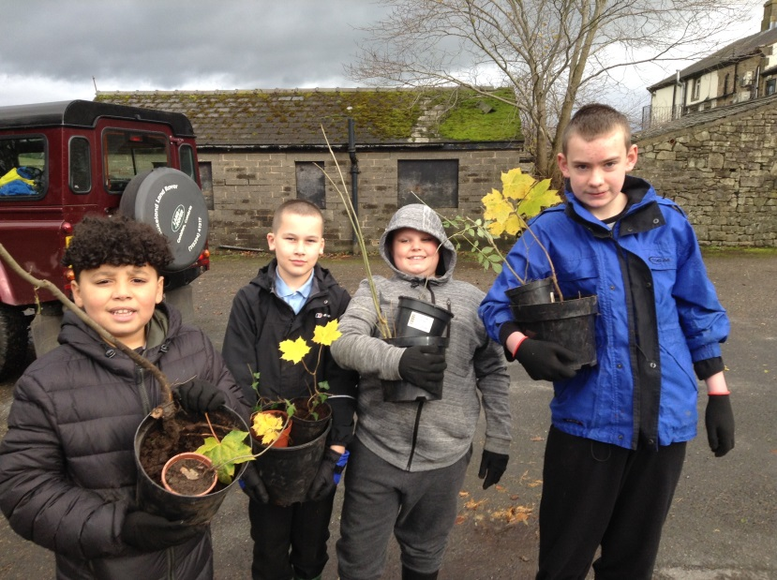
Remi Kaden Haydn Jamie
Their role will involve attending regular meetings hosted at Barnacre Road Primary School. They will meet other school champions and staff from our cluster schools and discus and plan activities that will help promote awareness and change. Their job is to communicate and inspire their peers and teachers and the wider community.

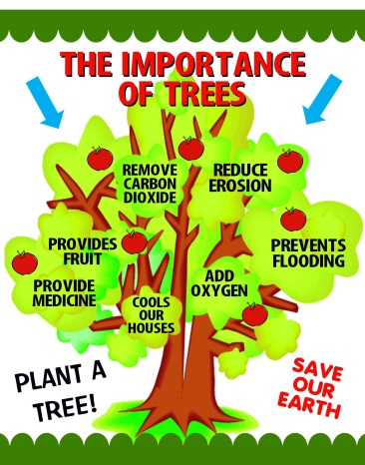
The first planning meetings took place in September 2019, it was decide by the group to focus on the value of trees and try and compensate in some way for the loss of trees.
Why are trees important?
1. They’re good for our mental health
2. They’re at home in our countryside
3. They can help us fight climate change
4. They help prevent flooding
5. They provide a home for wildlife
The initial activities planned to launch the project were for all cluster schools to collect and plant tree seeds. We are very lucky to have a wide variety of trees at Hillside. Pupils have already been collecting and planting seeds during Forest School sessions. These will be grown in the poly tunnel and eventually we will need to find somewhere to plant them.
We have also been donated tree saplings and hedges if any parents have any spare land at home and would be willing to plant a tree or some trees please lets us know.

Our Champions have already been on a tree planting day with the group. They planted trees on land owned by united utilities. We all had a great time meeting up and planting trees

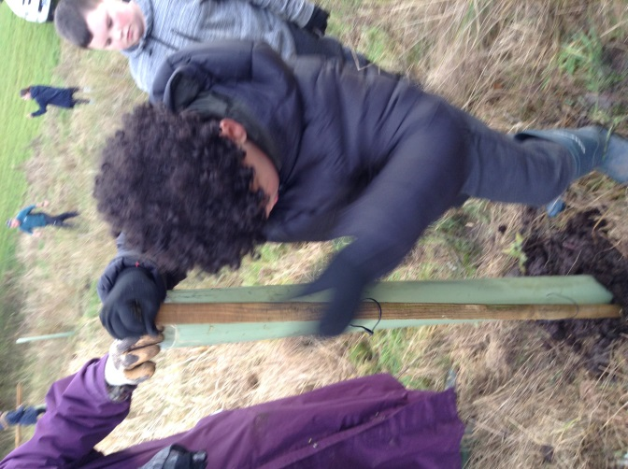
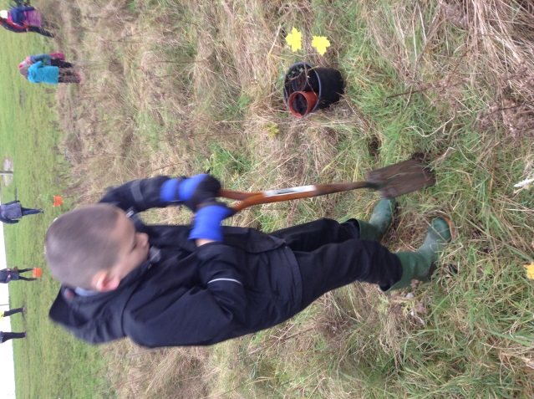
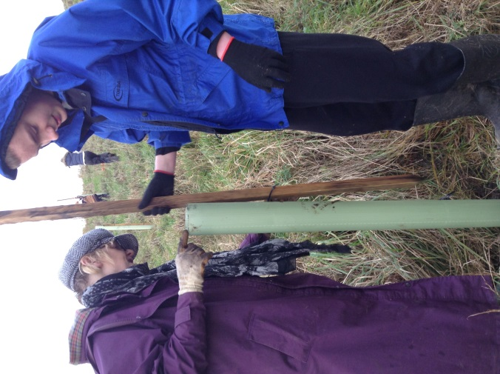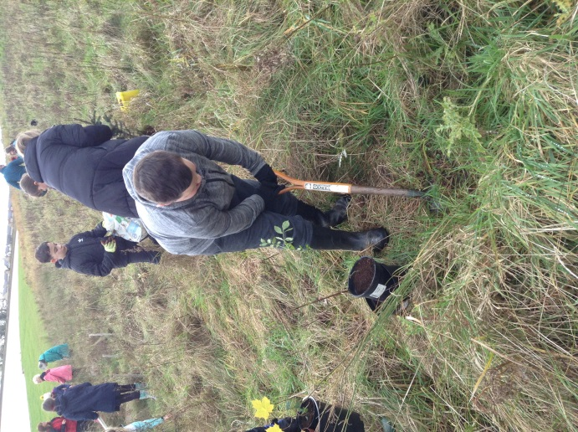
Our Champions will also be delivering special assembles in school to encourage awareness of taking care of our environment, climate change and how we can help.

