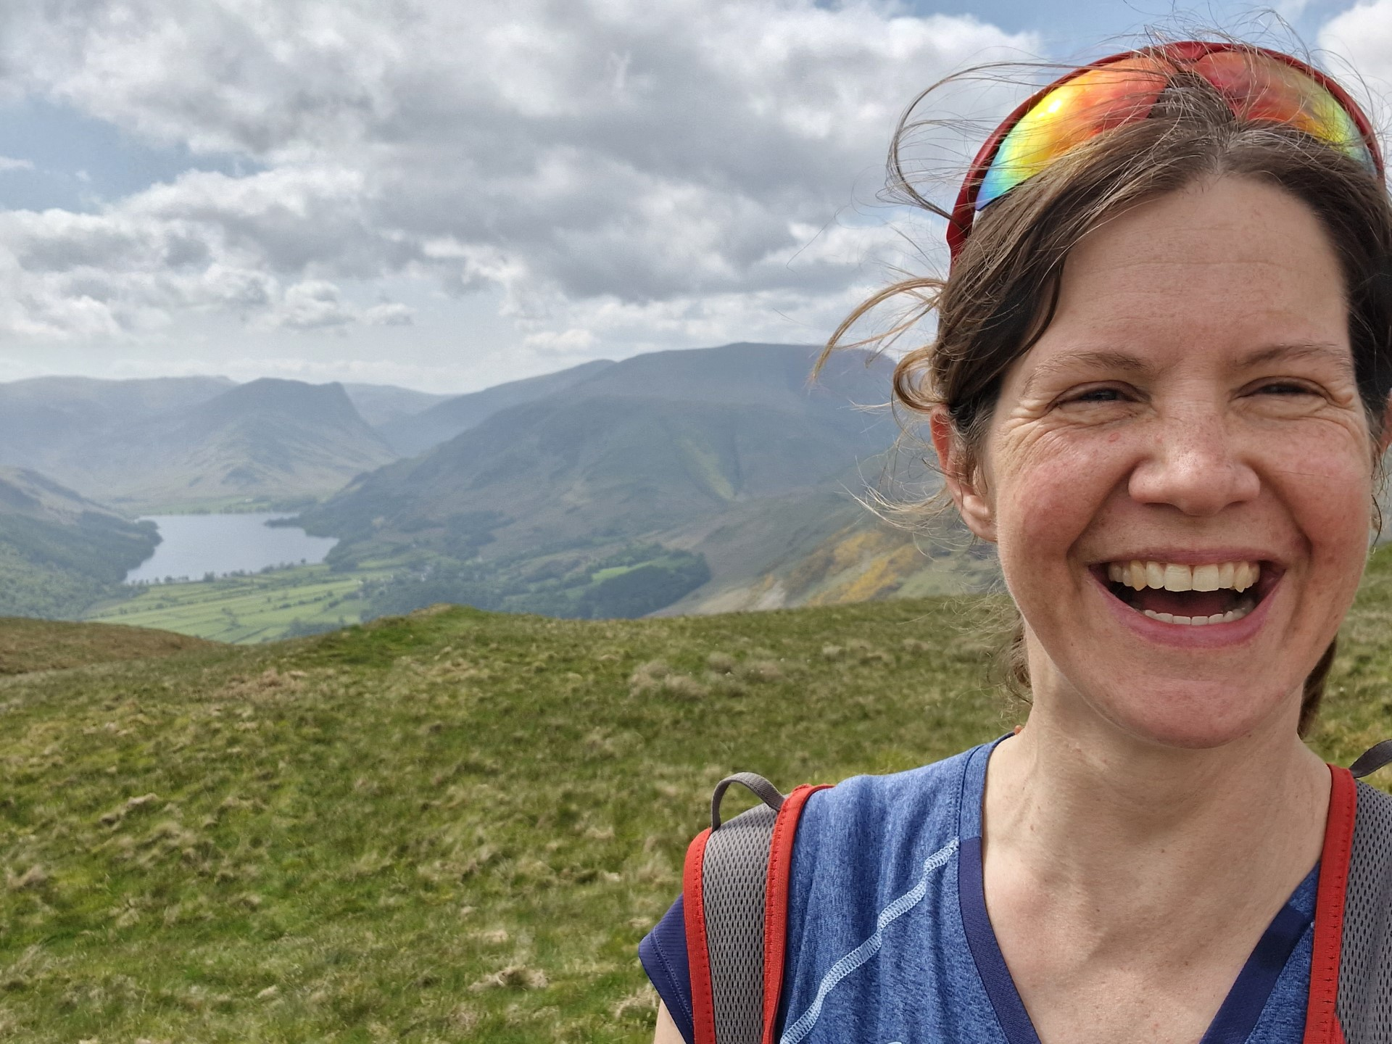

Who am I?
My name is Emily Fraser and I’m Hillside's Chair of Governors. I grew up in Longridge, but have lived in many places as an adult as my husband is in the Army. I now live in Fulwood with my husband, two sons and a black labrador. I love cycling, walking and baking,
Why did I become a Hillside Governor?
I have been a governor at Hillside since Summer 2022 and Chair since September 2023. Before moving back to Lancashire I was a governor at a primary school and many years before that I was a secondary school teacher and worked in a local education authority. Although I no longer work in Education, I still have a passion for it. My desire to learn more led to me applying to be a governor at Hillside, as I have no direct experience of a special school, but I am drawn to roles where I can support and learn from those with bigger hurdles in life than I do.
What do I bring to the governing body?
I currently work as an organisational development consultant in the NHS. This means that I help leaders and teams to learn to be the best they can be. This is why my first focus has been on the Vision and Values for Hillside. I have 10 years of experience in Human Resources, another 10 in Education and almost all of my career has been in the public sector. I bring many years of experience but also an enquiring mind, as I still have much to learn, especially Hillside, Autism and the current education system.

