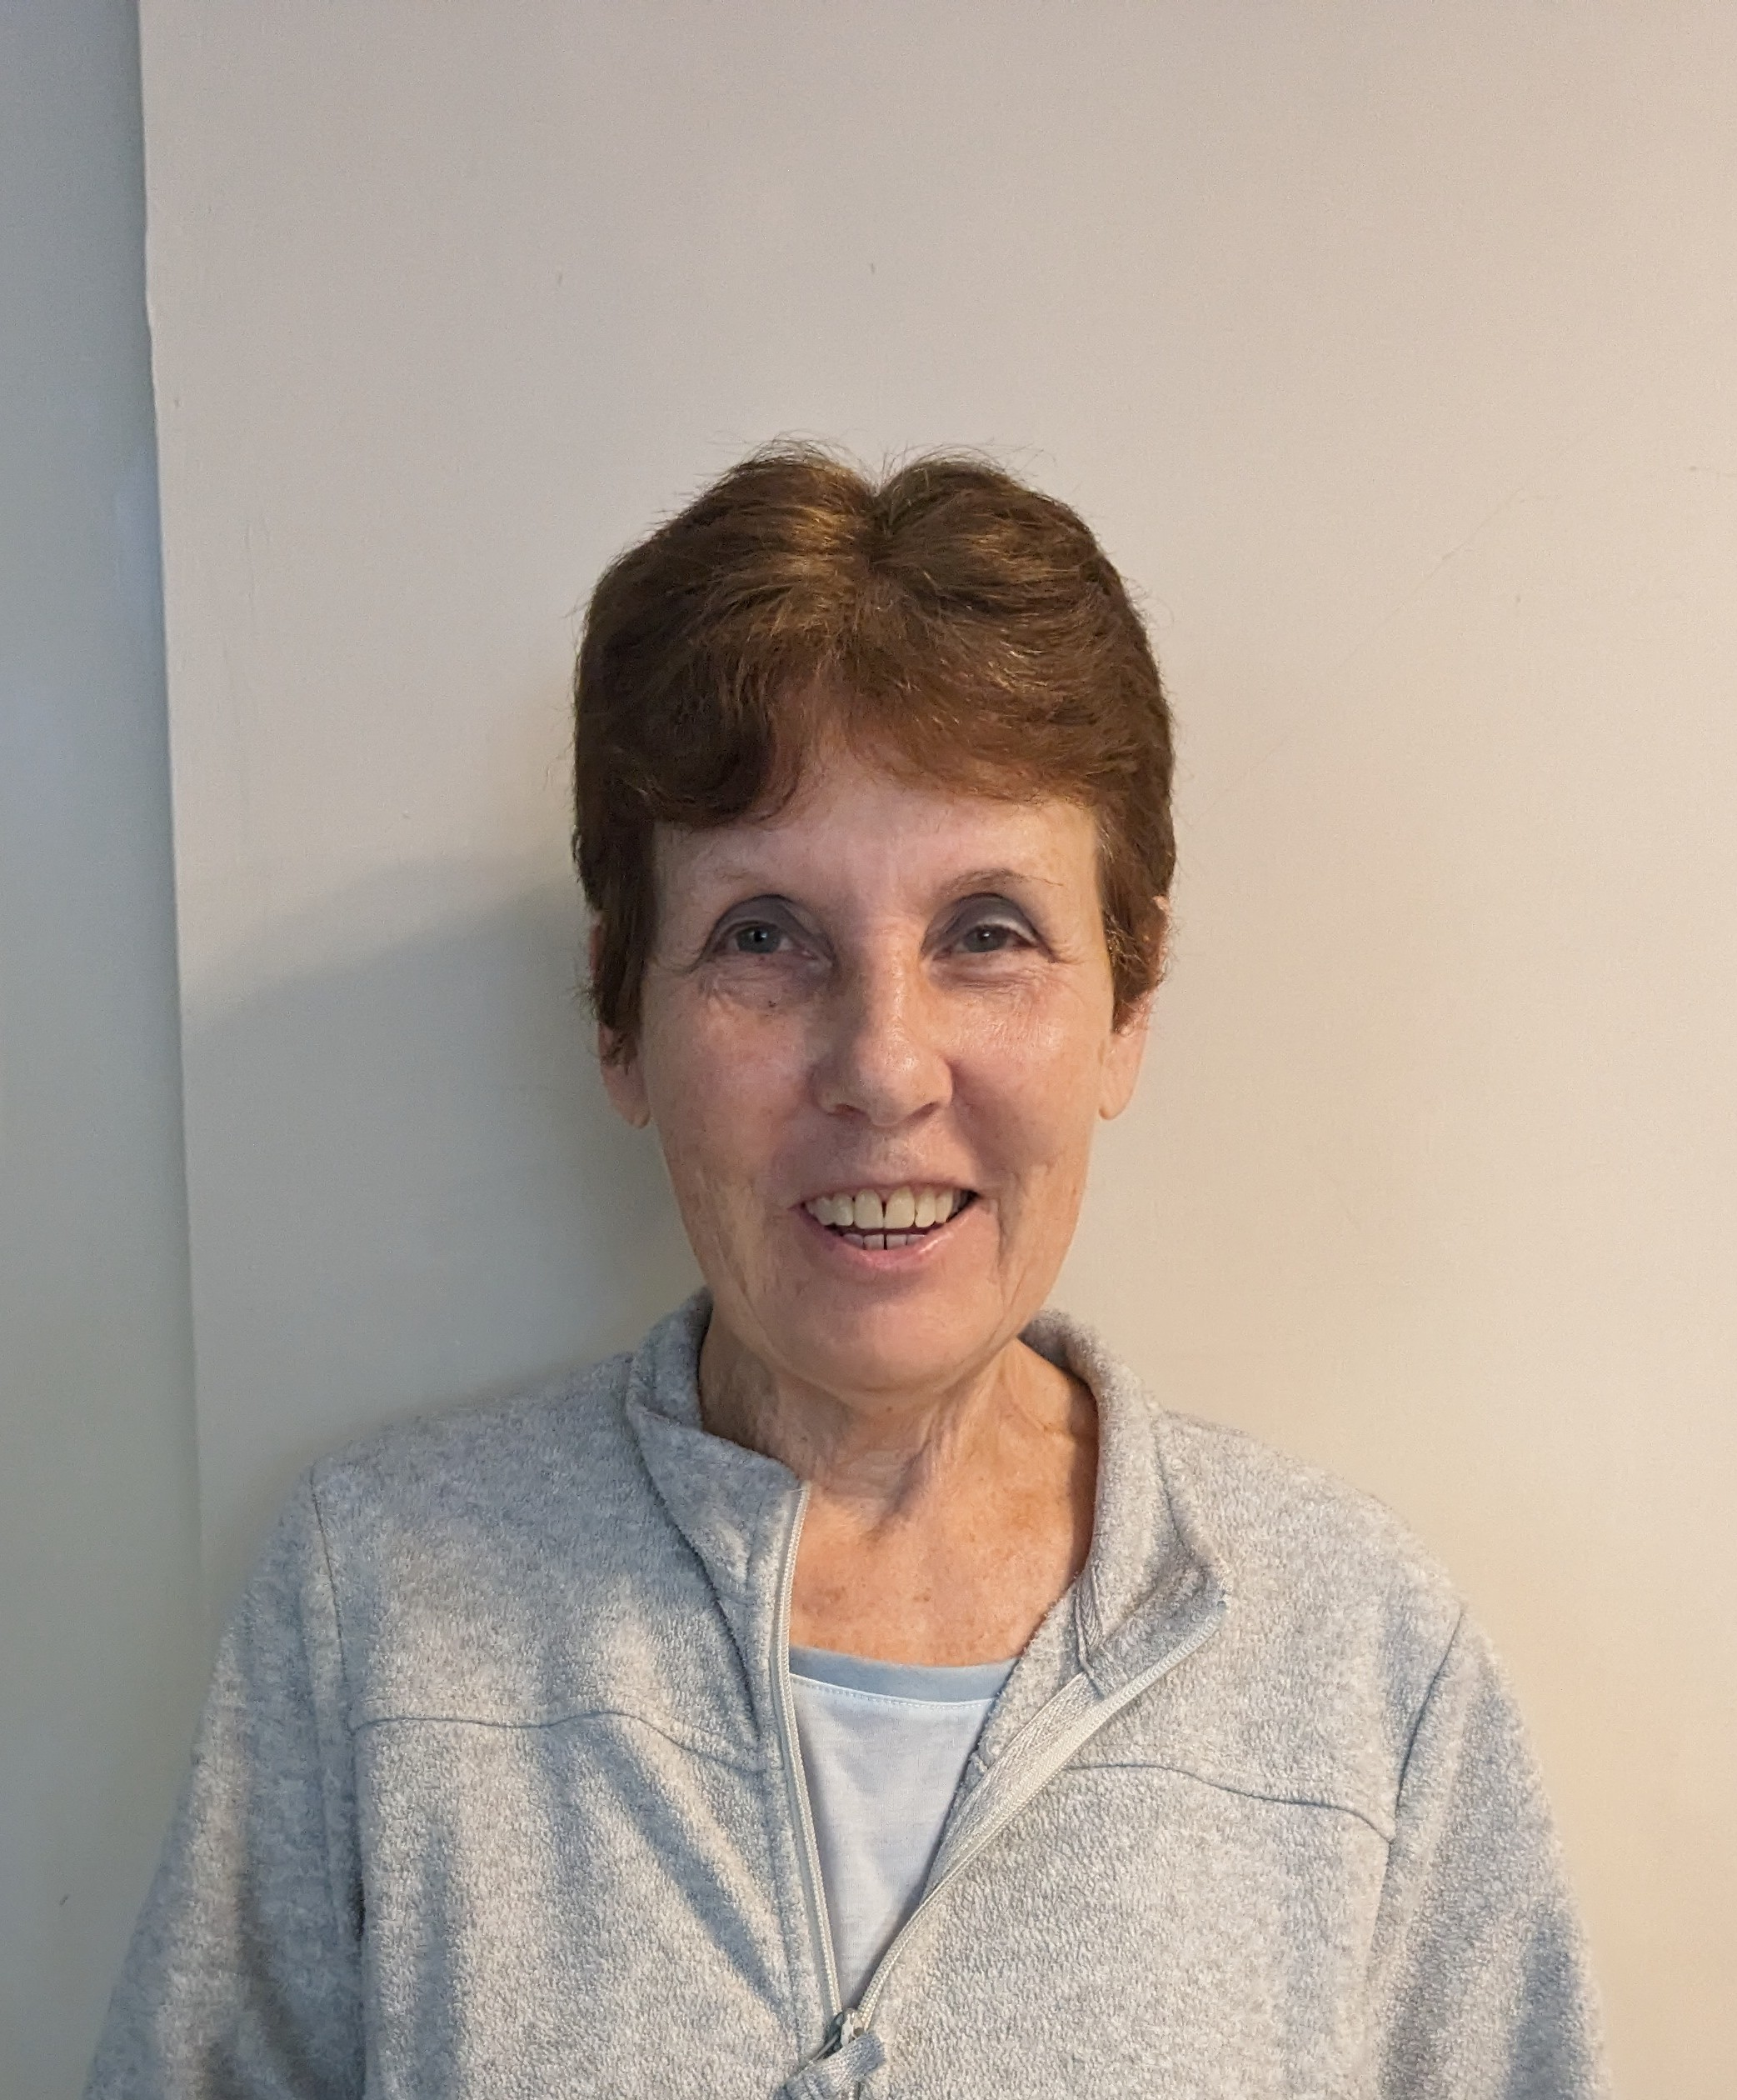

Who am I?
I am Carol and I am very excited to have joined the team at Hillside school and college. I have 4 grown up children 3 boys and a girl who have given me nine grandchildren. One of my sons lives in Sweden with three of my grandsons who I visit as often as I can.

Why did I become a Hillside Governor?
I have worked in social care in various roles and with different client groups for many years before retiring last year. I have developed a range of transferable skills which I believe I can use to benefit the pupils who attend Hillside school and college. Becoming a Governor at Hillside appealed to me because I am interested in supporting young people who have special educational needs.
What do I bring to the governing body?
I have experience of working with people who have mental health needs both in a hospital setting and the community. I have qualified as a mental health social worker and have managed services for people with learning difficulties who have moved from living at home to living independently in the community. Within this I have worked closely with families and other professionals such as housing and local colleges to ensure the young people received the right support to meet their needs at the right time in their lives. Safeguarding has been a major part of my role in all situations and have taken on the role of safeguarding lead in my previous roles. I understand that we need to ensure appropriate safeguarding training for everyone who is working with vulnerable people and children.
Through the management experience I have gained when working for NHS and the local authority and a number of charities I have been able to manage teams of people and have worked as part of a team. I am keen to use my skills and experience to work as part of the governing body and support the team to make decisions to benefit the school and its pupils.

