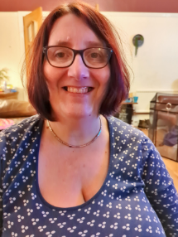
Who am I?
My name is Cheryl Doran. I am a busy mum of five children, albeit the three older ones no longer live at home. Jakey attends Hillside school. Annabel, Jakey’s sister, also has a diagnosis of autism but attends a mainstream school. I am a full time carer for both children.
I am also Co-Chairperson of Hillside PSFA
I also hold a TA3 qualification from my previous role in a specialist Discrete Autism Unit within a specialist setting. I had this role for 10 years.

Why did I become a Hillside Governor?
By becoming a school Governor, I feel that this gives me a chance to help to make a difference to my child’s education and future children’s education. I believe that the knowledge and experience that I have as both a parent and a former TA3 in a specialist setting are transferable to the Parent Governor role.

What do I bring to the governing body?
I consider myself to be a very approachable and honest person. I understand completely what it is like to be a parent to children with additional needs. I consider myself to be empathetic and can work well as part of a team.

